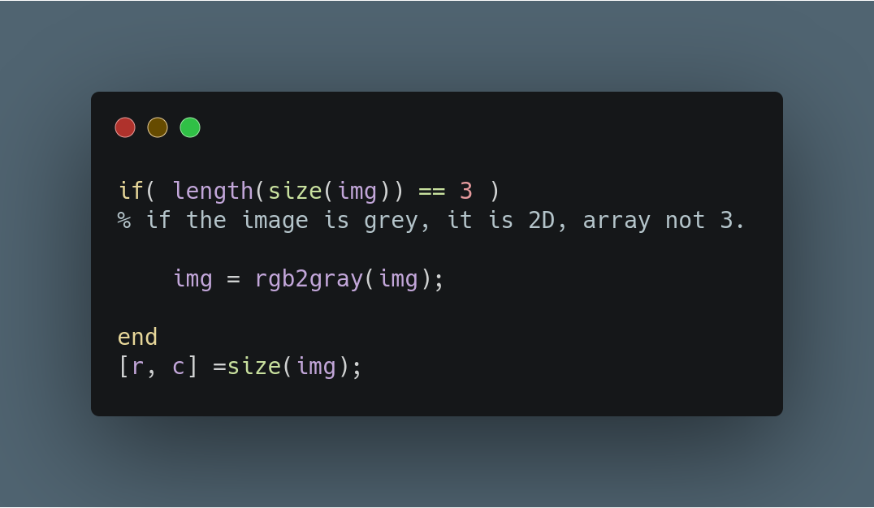

Assingment 1:

Before starting, the following code is written because of any assumption cannot be made about image’s type. However, one of my mistakes is, instead of creating another MATLAB script to check validity of image and converting them, I just add this part to begging of some of my scripts.

In first task, what we are trying to achieve is scaling the image linearly. Linear scaling is a point operation which arrange histogram of image and make him stretched across the possible pixel values, - 8 bit pixels == 0-255 value range.

To linear scale we use the following formula:
g(u)= b*(u-a) where a is minimum value and b = Gmax / (u_max-u_min)
Gmax= 255 because maximum value a pixel can ever take is 255. In the next page, you can find my all code.

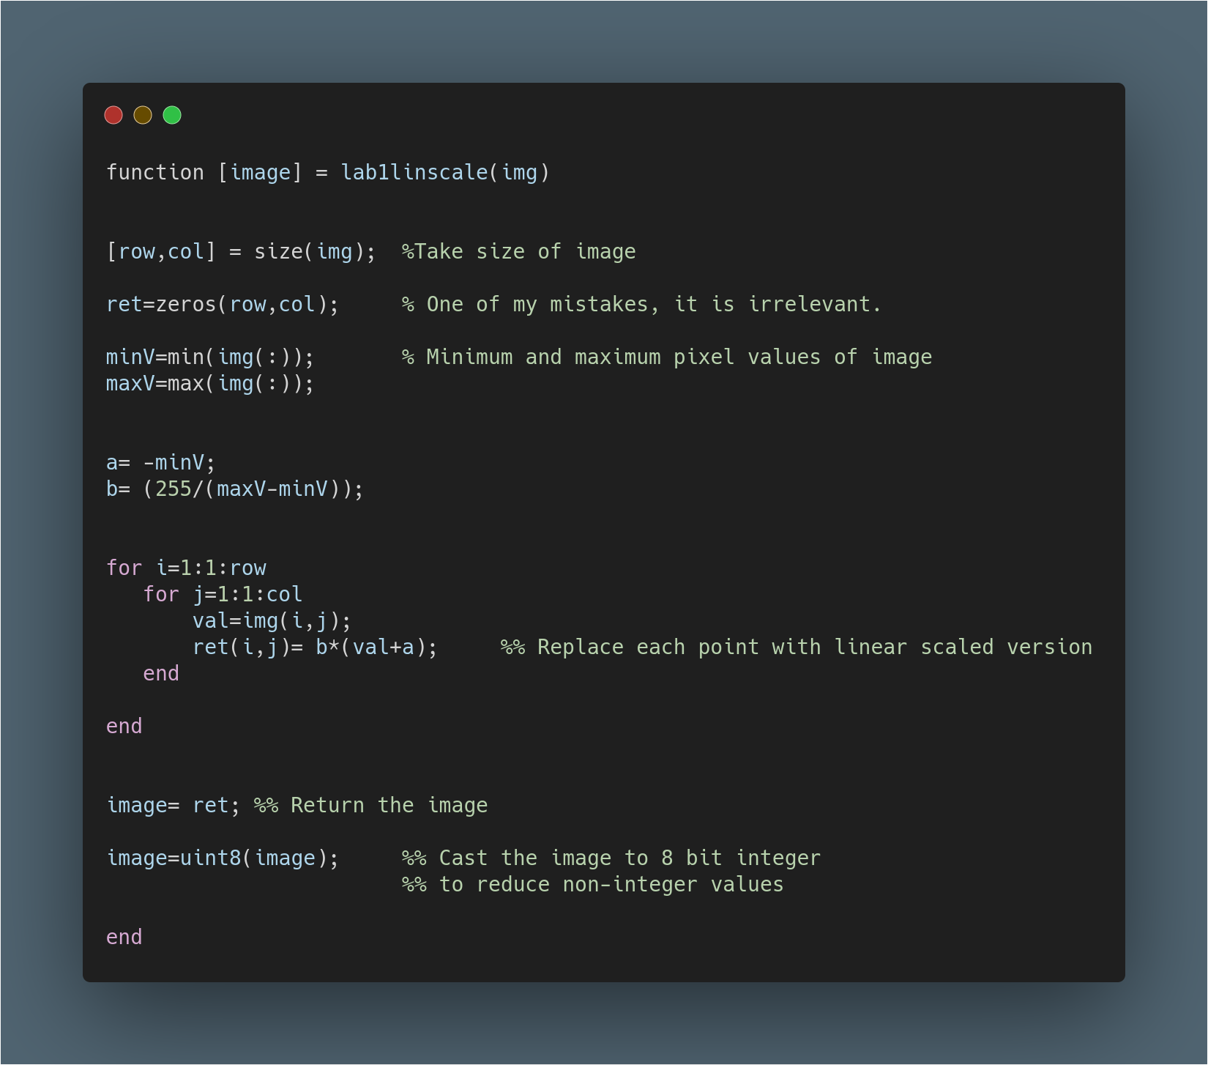

In the next page you can find result. However, It does not seems like linearly scaled. Unfortunately, I have failed the first task. Please check the results.

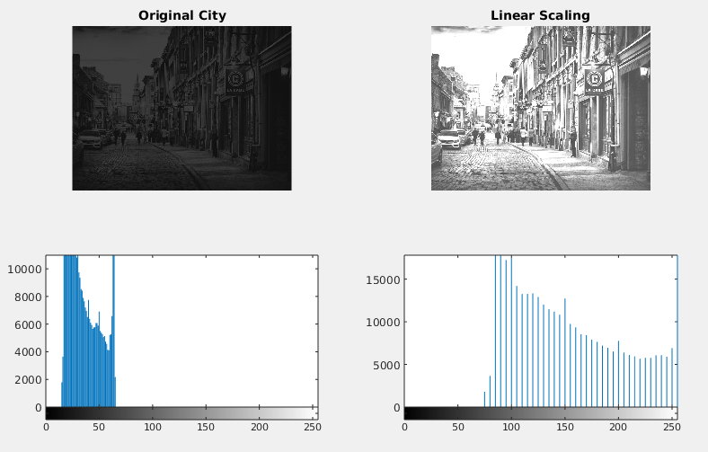
The mistake that I made:
In my submitted code, I have to forgot to convert image to double values. Result of that, I calculated incorrect ‘b’ value and failed the linear scaling.
However, I corrected the code and obtain proper results. Only one line added corrected version of my code and results placed in below.

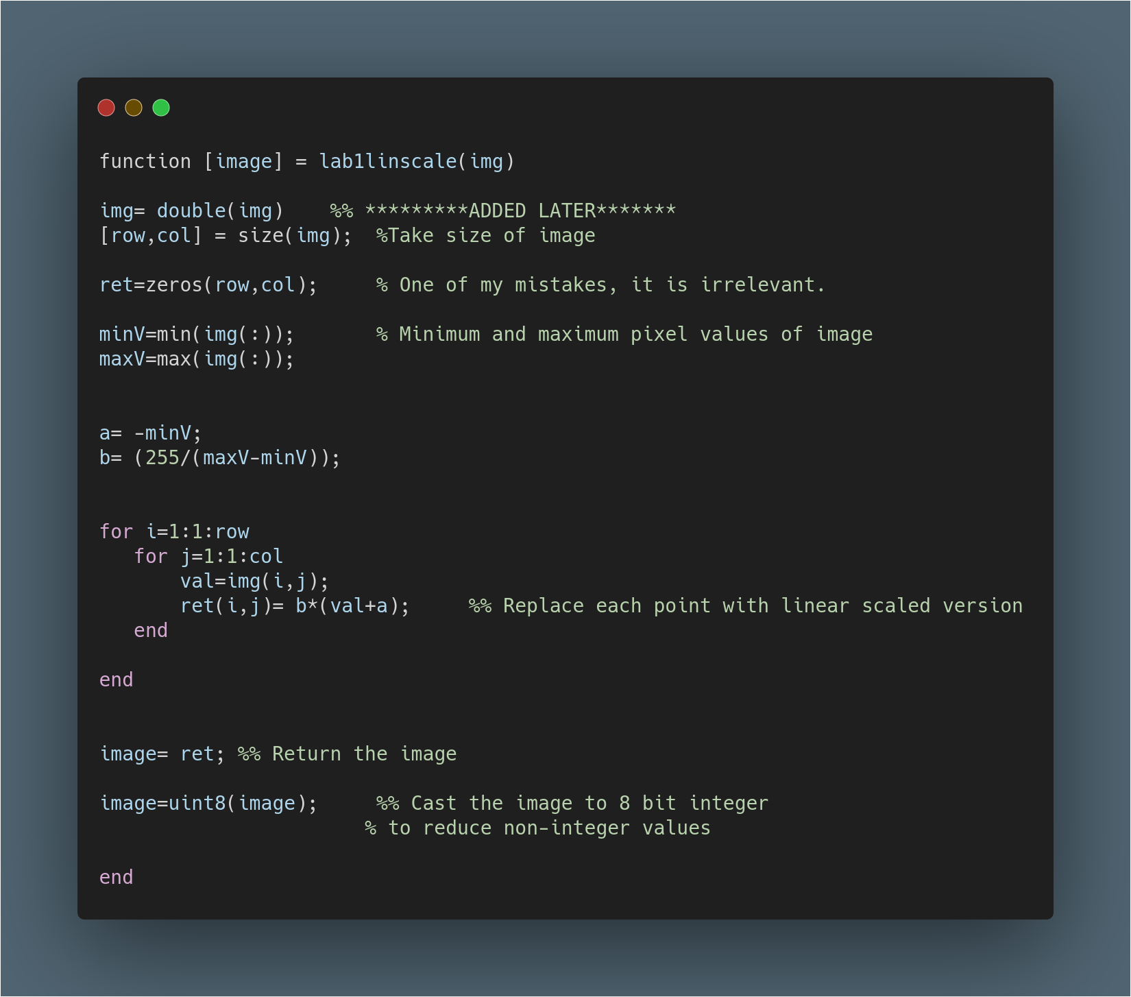
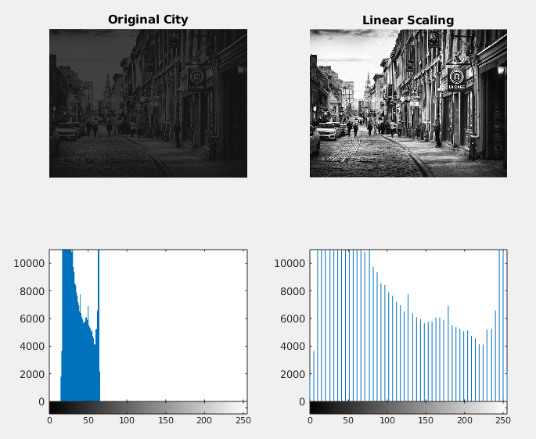

Self-Critisism for Task 1:

- I could not manage to time well and forgot to put histograms of images to my lab submission.
- I did not put any comment on my codes due to time limitation and stress of my first lab.
- I created an 2D image matrix by zeros to use later, however, forgot the delete and it just seems irrelevant.
- There was a division operation so I could get non-integer results. I missed that and instead of casting the pixels to double, I used the integer matrix and get wrong result. Also, lack of histograms let me believe that I manage the task 1 successfully.
- I unintentionally assumed the input image will be gray-scale by looking at the example image. Therefore, my code would not work with RGB images.
- Nevertheless, I implement the formula and get a result successfully.

Assignment 2:

